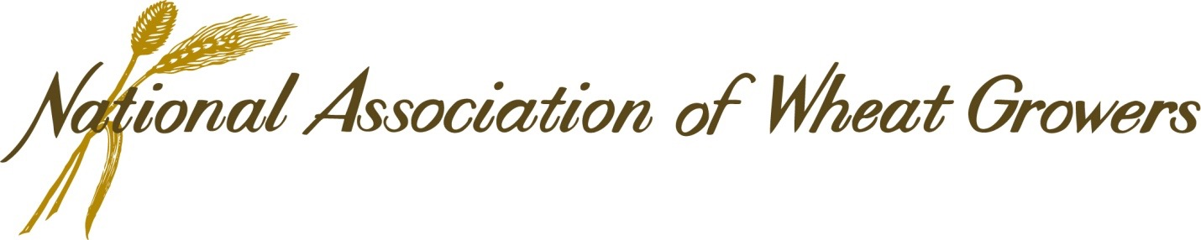
415 Second St. NE, Suite 200 • Washington, D.C. 20002 • (202) 547-7800 • www.wheatworld.org

September 3, 2019

Charles Smith
Acting Director, Pesticide Re-Evaluation Division
Office of Pesticide Programs
OPP Docket
Environmental Protection Agency Docket Center (EPA/DC), (28221T)
1200 Pennsylvania Ave. NW
Washington, DC 20460–0001

RE: Docket Number: EPA-HQ-OPP-2009-0361-2340

Dear Mr. Smith:
The National Association of Wheat Growers (NAWG) appreciates the opportunity to comment on the interim registration decision for glyphosate (Docket Number: EPA-HQ-OPP-2009-0361-2340). NAWG is a federation of 20 state wheat grower associations that works to represent the needs and interests of wheat producers before Congress and federal agencies. Based in Washington, D.C., NAWG is grower-governed and grower-funded, and works in areas as diverse as federal farm policy, trade, environmental regulation, agricultural research and sustainability.
NAWG members appreciate the thorough review that Environmental Protection Agency (EPA) undertakes to ensure that all pesticides a safe for growers to use and are also safe for the environment and consumers. Wheat growers work every day to produce a safe, affordable crop that balances crop rotation, input costs, production goals, and improvement of natural resources to protect the long-term sustainability of their farming operation. This is driven by the need to provide a lifelong business for their families, potentially across multiple generations. Our grower members rely on the EPA to assess all pesticides to ensure their safety, efficacy and provide appropriate requirements on their use. The pesticide label is the law and we follow the label requirements when using glyphosate and any other approved pesticide.

Glyphosate has been on the market for over 40 years (1974 initial registration), has passed multiple scientific reviews in each of its over 100 registered countries. The scientific review of glyphosate has been substantial, with one of the most extensive worldwide human health, safety and environmental databases ever compiled for a crop protection product. This safety record and documented science peer-reviewed research supports a review process based on sound science. Wheat growers rely on EPA to review scientific research studies and make determinations of safety for all pesticides. Federal laws require EPA to protect human health and safety through the review, registration, and labeling of pesticides. The application of appropriate safety factors are used to ensure that sensitive populations, such as children and agricultural workers, are protected under the labeled use of each pesticide.
Glyphosate is an exceptional product for wheat growers because of its ability to effectively control a broad spectrum of plants post-emergent. Rather than using tillage to eliminate emerged weeds in their fields prior to planting, growers, instead, apply a labeled treatment of glyphosate to the weed growth. Undesirable plants that would otherwise provide competition for water and nutrients to the crop are controlled without using a tillage trip across their fields. Thus, glyphosate allows for direct seeding without disturbing the soil. This conservation tillage practice enables growers to leave the crop residue on the surface of the field. Maintaining residue on the field without disturbing the soil with tillage protects the soil from wind erosion, preserves moisture, preserves nutrients, and improves soil health. Direct seeding and conservation tillage have proven to sequester carbon in the soil, producing a carbon sink on farms. Keeping residue on the field serves as a mulch, allowing the soil to retain moisture and increase water filtration into the soil, reducing the amount of water that runs off the field. According to USDA, conservation tillage practices are used by wheat growers on 67% of wheat acres in 2017, up from under 40% in 2004. Reducing tillage trips across the field is a conservation practice wheat growers know has a positive impact on their ability to produce a quality crop over wide variation of climatic conditions. Conservation practices preserve the environment and improve soil health, sustaining the long-term viability of the farming operation. This would not be possible without the use of glyphosate. This unique product is critical to the sustainability of wheat production in the United States long term.
In semi-arid regions of the U.S., wheat is occasionally produced is successive years on the same field due to the limited crops that are adapted to dry climates. Volunteer wheat plants growing from the previous crop can harbor disease, providing a continued host to infect the new crop. These volunteer wheat plants must be removed to break the link of disease transfer, which enables a healthy new wheat crop. Using glyphosate prior to planting the new crop allows wheat growers to seed into residue on the field but ensures that any volunteer wheat from the previous crop and existing weeds in the field are removed.

Another labeled application for glyphosate in wheat is a pre-harvest treatment. Wheat growers can use glyphosate prior to harvest to dry green weeds that may be present in the ripe wheat field. This allows the mature wheat grain to dry naturally in the field, enabling a timely harvest. This application is used infrequently, on less than 3% of all wheat acres annually, and replaces mechanical mowing/swathing of wheat to dry the green weeds. At the time of this treatment, the wheat kernel development is complete, the crop has matured and contains less than 30% moisture in the grain. Glyphosate is applied at least 7 days prior to harvest. The option to use this EPA labeled treatment enables wheat growers the ability to adjust their practices at harvest when weather conditions present new obstacles to manage.
The specifications on the product labels are reviewed by growers regularly and the proposed label changes in the EPA’s interim registration decision that affect wheat are acceptable to wheat growers. Our review of the proposed changes included a discussion on the restrictions related to temperature inversions. Our members encourage the EPA and States provide additional information on temperature inversions to help educate farmers on its identification, measurement and additional tools be made available to help recognize them. Our member wheat growers want to remain in compliance with this and other pesticide label changes.
Critical to wheat growers’ operations is the understanding of the benefits and costs of all crop protection tools. Farmers trust the factual, science-based decisions of the Environmental Protection Agency’s (EPA) regulatory system to approve crop protection chemistry products and make them available for use based on their safety assessment and efficacy. Our growers honor the EPA approved, labeled use of these products to ensure no harm is placed upon their crops, their property and themselves, which preserves the viability of their farming operation. Farmers know that the label is the law and they must abide by the pesticide labels, or they risk the loss of their continued use.
The Federal Insecticide, Fungicide, and Rodenticide Act and the Federal Food, Drug and Cosmetic Act set strict regulatory standards for EPA for approving the use of pesticides and ensuring that our food supply is safe. EPA must find that a pesticide poses a “reasonable certainty of no harm” before it can be approved for use. Under the Food Quality Protection Act, reviews specifically address risk to children and add additional safety factors. When setting tolerance levels of remaining pesticide residue in grain or plant material, EPA takes into consideration diets of adults and children, ensuring a safe level. NAWG supports the U.S. Government regulatory system to ensure that crop protection tools are safe for grower use, farm worker use, and that any residue found on food is safe for human consumption, including consumption by children. These are processes that growers have confidence in providing a scientific assessment of each pesticide’s risk/benefit profile.

Farmers already know the importance of safe handling and application of pesticides and meeting federal and state requirements for their use. Farmers work hard to produce a high quality, safe product for their consumers. Understanding and following the strict requirements of the pesticide label is a part of the proper management of a grower’s operation, which also protects their workers, their communities, themselves and their consumers.
Thank you for the opportunity to provide comments. Glyphosate is an exceptional product for wheat growers and NAWG supports the continued labeled use in the U.S. based on the extensive safety and efficacy data EPA has reviewed to register the product.

Sincerely,
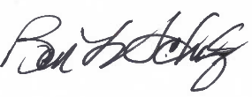
Ben Scholz
President, National Association of Wheat Growers

